1. **INTRODUCTION**

**COMPANY BACKGROUND**

**HISTORY**

Arellano University in Pasay hats its modest beginnings at the Apolinario Mabini High School corner Donada & Menio streets in SY 1987-1979. It moved to its present location at Jose Abad Santos High School grounds in SY 1986-1987, and there it has burgeoned to what it is today and now called Arellano University – Jose Abad Santos (AU-JAS).

The courses offered at School of Computer Studies (SCS) were Bachelor of Science in Computer Science and Bachelor of Science in Information Technology and it was in 2010 when Bachelor of Science in Information System became available.

Arellano University President, Francisco P. Cayco would often times urge the studentry to be hardworking and productive. This call was heeded by a big number of part-time students from Pasay and other outlying areas, who would want to take the opportunity of working for a college degree after office hours.

For its mission, AU-JAS aims to promote the development of youth in a healthy, intellectual atmosphere and to assist in the transformation of the youth into productive, progressive and actively concerned Filipinos.

AU Pasay is the second school of the freedom-loving Filipino.

**MISSION**

The mission of the College is to develop and produce socially responsible, globally competitive and competent Information Technology (IT) professionals.

**VISION**

The vison of the College is to be recognized as a center for excellence in Information Technology Education.

**BACKGROUND**

A reservation system is a computerized tool wherein an information can be saved and obtained. It is also used to perform actions or transactions in relation to room and car rentals, travels and other activities. (ConceptDraw, n.d.)

A projector is a device that replicates the image to a surface, screen or wall. A large screen is usually used so that everyone in the room can see what is projected. A projector can reproduce slides from powerpoint presentation and videos when connected to a computer. (Hope, 2017)

The professors use the projector so that students can have easier way of taking down notes, it provides professors with greater teaching versatility because it frees the professors from using chalk and erase white boards, using projectors can be a better way of using class time because professors do not have to write down notes in the board and erase them due to space limitations and for students, using projectors means better class presentation. Creating power point presentations for class projects. (Whitaker, 2018)

The School of Computer Studies (SCS) at Arellano University – Jose Abad Santos (AU-JAS) allows the students and professors to use the available projector. There are two projectors, one designated for students and the other for professors. The AU-JAS, SCS is using a manual process in reserving a projector. This may result to redundancy of information and inefficient work balance as the process is repetitive. The department depends on the secretary in reserving the projector. Using pen-paper method to log the information of the borrower; hence subject to information getting easily loss and possible double reservation. This gives a negative impact to students, professors and also to the secretary on a busy day.

A well-designed, user-friendly reservation system would make it easier for students, professors and secretary to reserve the projector. This system will not only eliminate mostly of the company or organization’s pen-paper method of reserving the projector but it will also benefit the Department as well as the students and professors as this will be introduced as a new way of reserving the projector which is easier and faster than the method they are used to.

**GENERAL OBJECTIVE**

The general objective of the study is to develop a LAN-based projector monitoring system for the School of Computer Studies at AU-JAS Campus which is called *“PROSERVE”.* The system will be the main tool of the students and professors to reserve the projector.

**SPECIFIC OBJECTIVE**

1. Design and develop a system with the following features:
   1. Student Registration Module
   2. Professor Registration Module
   3. Login Form
   4. Forgot Password Link
   5. Reserve Projector Form
   6. Auto-generated Reservation Code
   7. My Reservations Module
   8. List of Reservation Form
   9. Accounts Module
   10. Monthly Reports Module
   11. Professor Reservation History Module
   12. Student Reservation History Module
   13. Admin: Terms and Condition Module
   14. Reservation conflict notification
2. Create the system using the following programming languages and tools:
   1. Hypertext Preprocessor (PHP) as scripting language for back-end functions
   2. Hypertext Markup Language (HTML) for front-end functions
   3. Cascading Style Sheet (CSS) for interface design
   4. Phpmyadmin 4.8.4 for database system
   5. JavaScript as scripting language integrated to HTML
3. To test and evaluate the system in terms of functionality, usability, reliability and security.

**SIGNIFICANCE OF THE SYSTEM**

Theprojector is one of the materials used inside classroom usually for presentation. The manual process of reserving the projector is difficult for people that is why the proponents decided to develop a system to replace the manual with computerized process of reserving the projector which is entitled PROSERVE.

**For Admin**

The repetitive process of browsing through the logbook whenever the students or professors who will borrow the projector will be eliminated. PROSERVE provide ease in tracking the availability and monitoring the status of the projector.

**For Students**

PROSERVE will minimize the queue time whenever the projector will be reserved and can be accessed without going to the admin’s office.

**For Professors**

PROSERVE will minimize the queue time whenever the projector will be reserved and can be accessed without going to the admin’s office.

1. **ANALYSIS OF THE CURRENT SYSTEM**

**Hardware Set-up**

The SCS at AU-JAS seems to be comfortable with the current manual process or having the pen-paper method.

Logbook/ Notebook. The admin of the SCS keeps track of the borrowers of projector through this material. Each page represents a date of the month, takes down the time, name and student ID and course of the student borrowing/ reserving the projector. The students and professors meet with admin to know the availability of the projector and reserve or book the projector on the schedule they prefer. The students and professors will then go to the SCS office to get the projector on the scheduled date. All are mere manual process and no software nor application is being used in their current process.

**Personnel Involved**

***Admin***. The current employee who acts as the secretary of the department and also in charge in tracking down the availability of the projector, taking down the request date and time and the borrowers information. The Admin is also responsible for releasing and accepting the projector.

***Students and Professors***. These are people borrowers of the projector.

Students. These are people borrowers of the projector. These are irregular and regular students enrolled in the current school year.

Professors: These are people borrowers of the projector. These are full-time and part-time faculty members teaching in the current school year.

**PROBLEM DEFINITION**

1. How do users reserve the projector?
2. How do users easily and conveniently know the availability of the projector?
3. How does the admin make sure that personal information are safe?
4. How does the user cancel the reservation?
5. How can a successful reservation be confirmed?
6. How does the admin make sure that the logbook that contains reservation details is safe?

**User Requirement Analysis**

Since the current process is done manually, all are based in a pen-paper method.

An enrolled student and professors are eligible to reserve or borrow the projector through the admin. The borrowers must ask the secretary of the SCS department if the projector is available on the time the students or professor needs it. After which, once available and agreed that the projector will be borrowed, the secretary will get the name, course, student ID or employee ID and date and time for record keeping.

The borrowers will then come back to the secretary to retrieve the projector on the schedule they have reserved.

1. **DESIGN OF THE PROPOSED SYSTEM**

PROSERVE is a LAN-based projector monitoring system made specifically for the School of Computer Studies of Arellano University – Jose Abad Santos Campus where the users and admin can reserve and see the availability of the projector. This system will eliminate the manual step of logging the information of the borrowers once a reservation is to be made.

**Proposed System Flowchart**

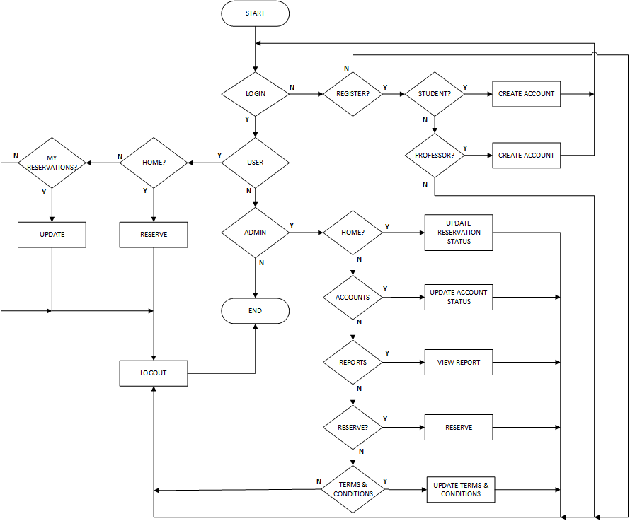

***Fig 1*** Proposed System Flowchart

Fig 1 shows the Proposed System Flowchart. This shows the overview of the proposed system called PROSERVE. The user will have an option between Student and Professor upon registration. The admin has Home, Accounts, Reports and Reserve tabs.

**Current Process Flowchart**

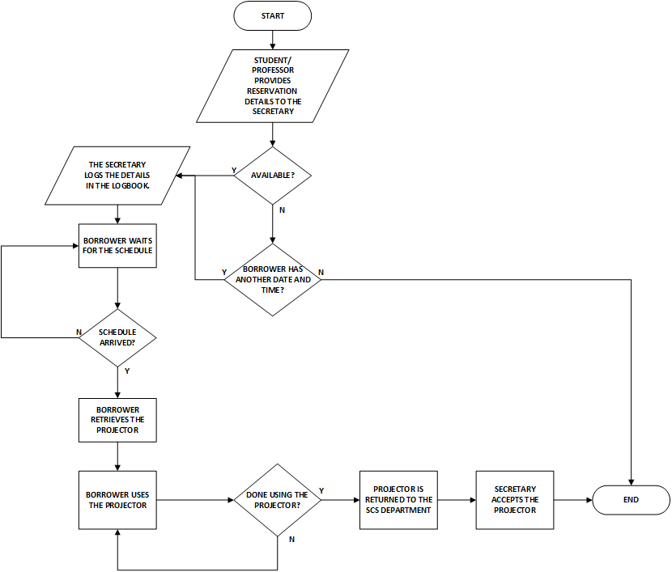

***Fig 2*** Current Process Flowchart

Fig 2 shows the current process flowchart on how students and professors reserve or borrow the projector. The students and professors have to meet the admin to know the availability of the projector, to reserve, to get and to return the projector to the SCS department.

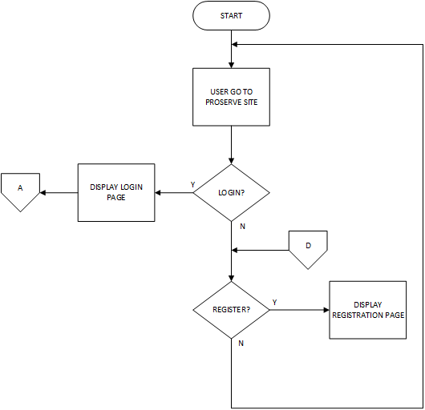

**Fig 3** Proposed System Flowchart – Home Page

Fig 3 shows the flowchart of the home page which contains the login and register buttons.

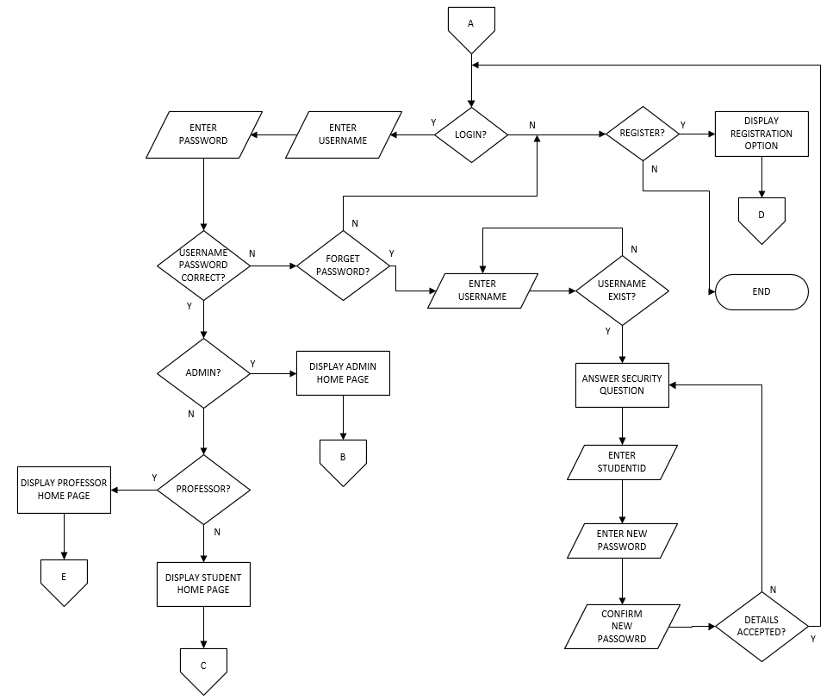

***Fig 4*** Proposed System Flowchart – Login Page

Fig 4 shows the login page that contains the Forgot Password option, Login and Register.

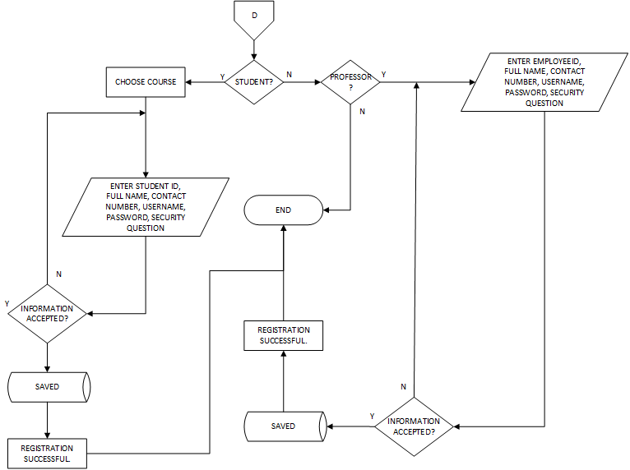

***Fig 5*** Proposed System Flowchart – Registration Page

Fig 5 shows the Registration Page which lets the user choose between student and professor. The user has to fill out the required fields to be able to register successfully.

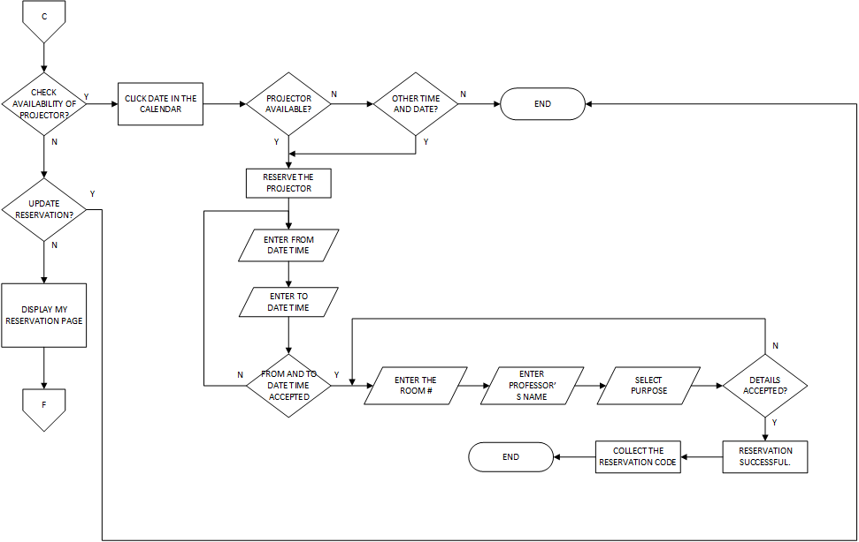

***Fig 6*** Proposed system flowchart – Student’s Interface

Fig 6 shows the Student’s Interface which contains Home and My Reservation Tabs. The user will have to click on the date on the calendar and fill out the required fields to reserve.

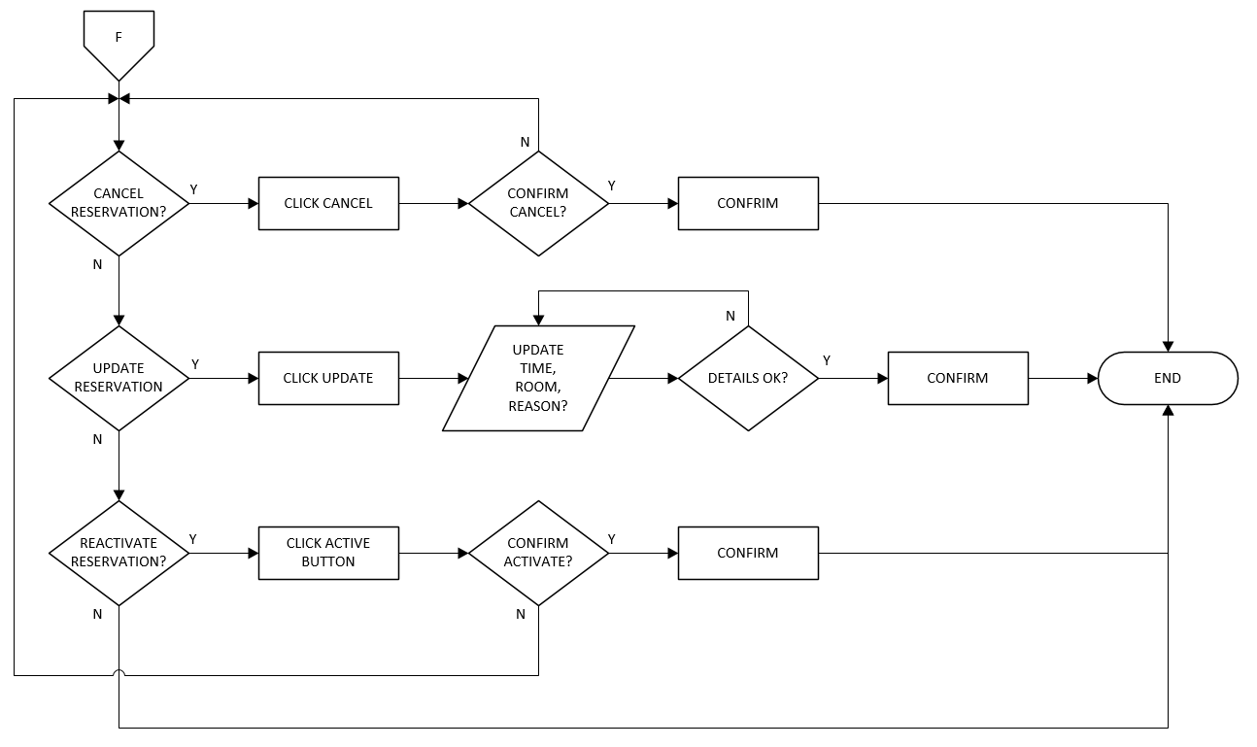

***Fig 7*** Proposed system flowchart – Student’s My Reservations Page

Fig 7 shows the list of reservations made by the users which they can Update or change the status to Cancel or Active.

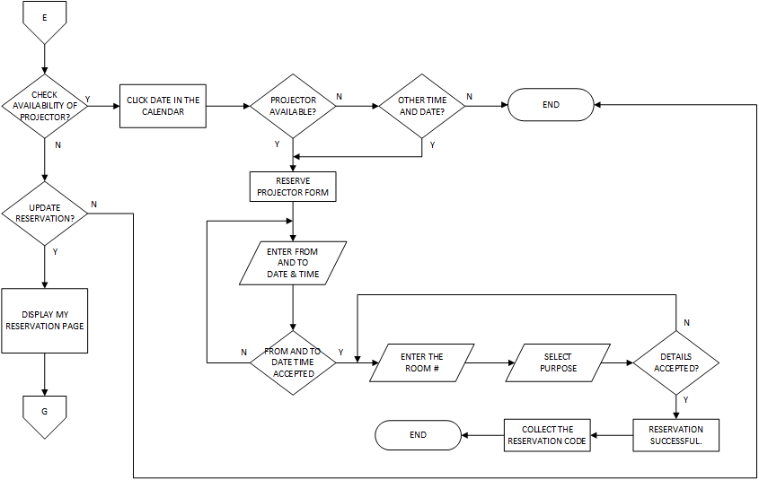

***Fig 8*** Proposed system flowchart – Professor Home Tab

Fig 8 shows the Professor’s Home Tab which where the user will have to click on the date on the calendar and fill out the required fields to reserve.

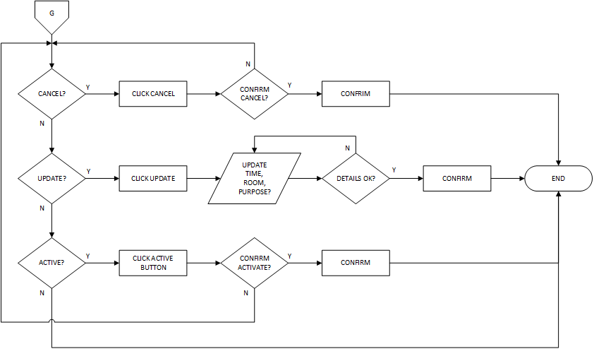

***Fig 9*** Proposed system flowchart – Professor My Reservation Page

Fig 9 shows the list of reservations made by the user which they can Update, or change its status to Cancel or Active.

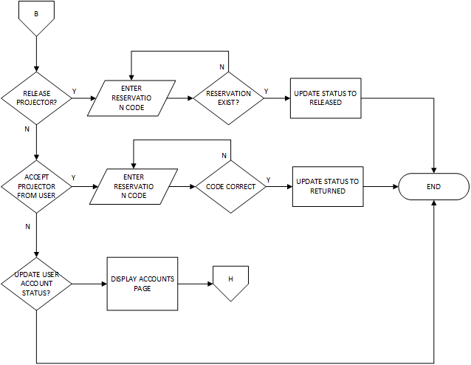

***Fig 10*** Proposed System flowchart – Admin’s Home Tab

Fig 10 shows The Home Tab which shows the list of reservations made on the present day where the admin can change the status of the reservation to Waiting, In Used or Returned.

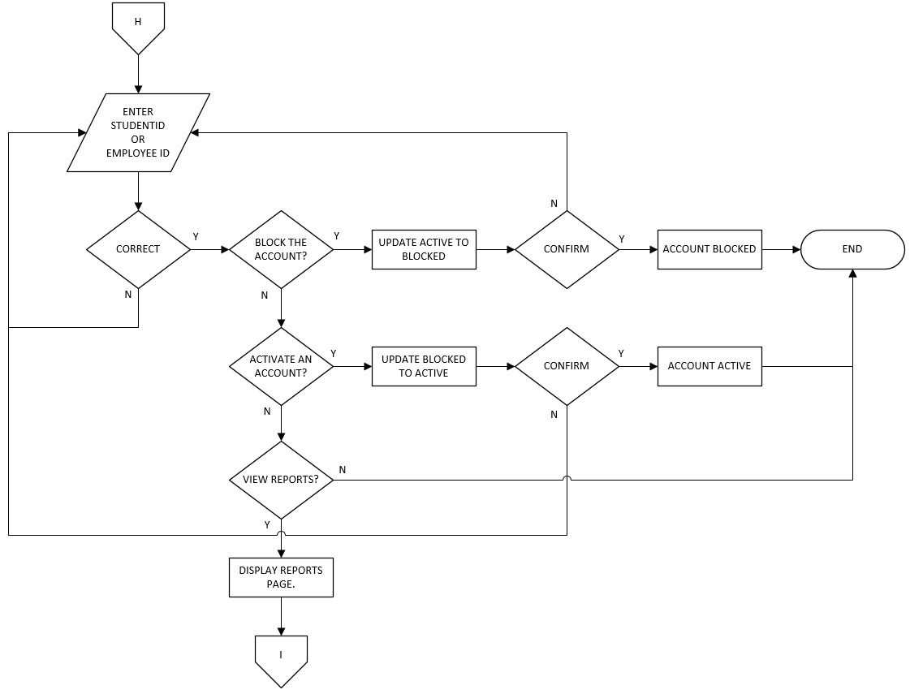

***Fig 11*** Proposed System Flowchart – Admin Accounts Tab

Fig 11 shows the Admin’s Accounts page which displays all the registered accounts where the admin can change the status to Inactive and Active.

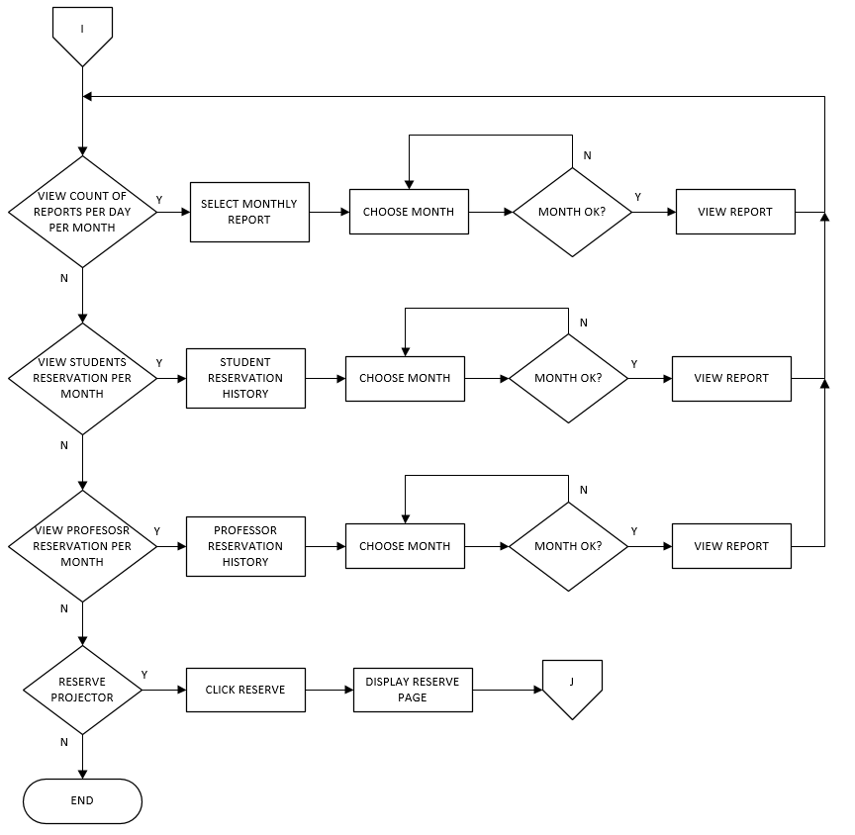

***Fig 12*** Proposed System Flowchart – Admin Reports Tab

Fig 12 shows the Admin Reports Page that contains Monthly Report button where the number of reservations will be displayed, Student Reservation History and Professor Reservation History buttons where the detailed monthly list of reservations made will be displayed.

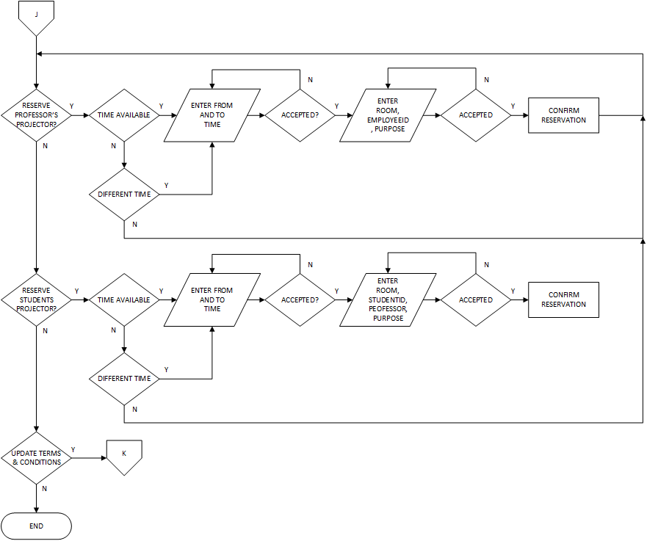

***Fig 13*** Proposed System Flowchart – Admin Reserve Tab

Fig 13 shows the Reserve tab which displays the calendar, list of reservations and Reserve Projector Form where reservation can be made.

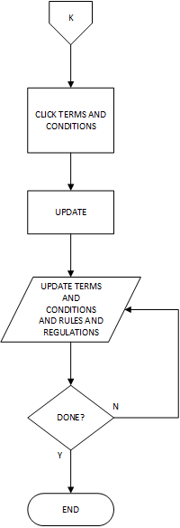

***Fig 14*** Proposed System Flowchart – Admin Terms and Conditions Tab

Fig 14 shows the Terms and Conditions Tab which displays Terms and Conditions and Rules and Regulations in reserving the projector where it can also be updated.

**DATA FLOW DIAGRAM**

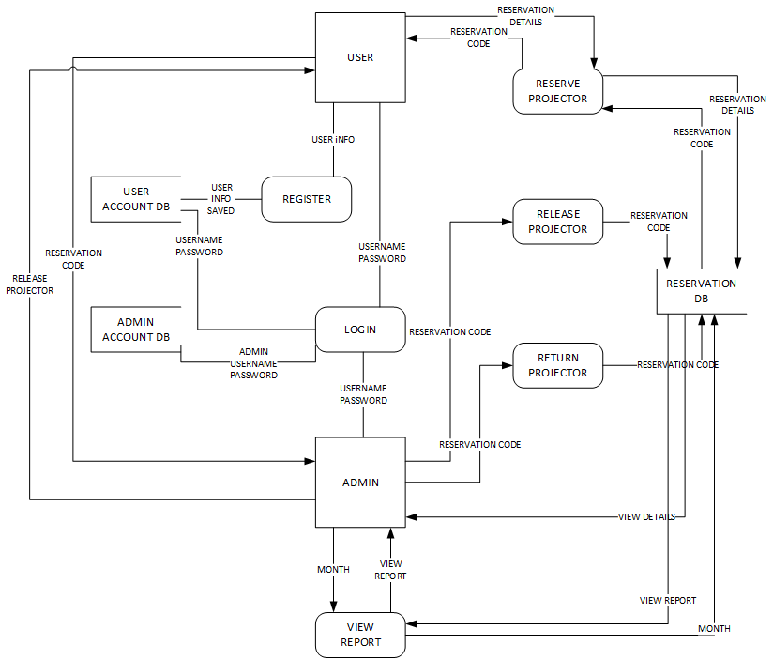

***Fig 15*** Data Flow Diagram of PROSERVE

Fig 15 shows how the data of the user is being collected and saved in the system. This also shows how PROSERVE provides the auto-generated code to the users.

**ENTITY-RELATIONSHIP DIAGRAM**

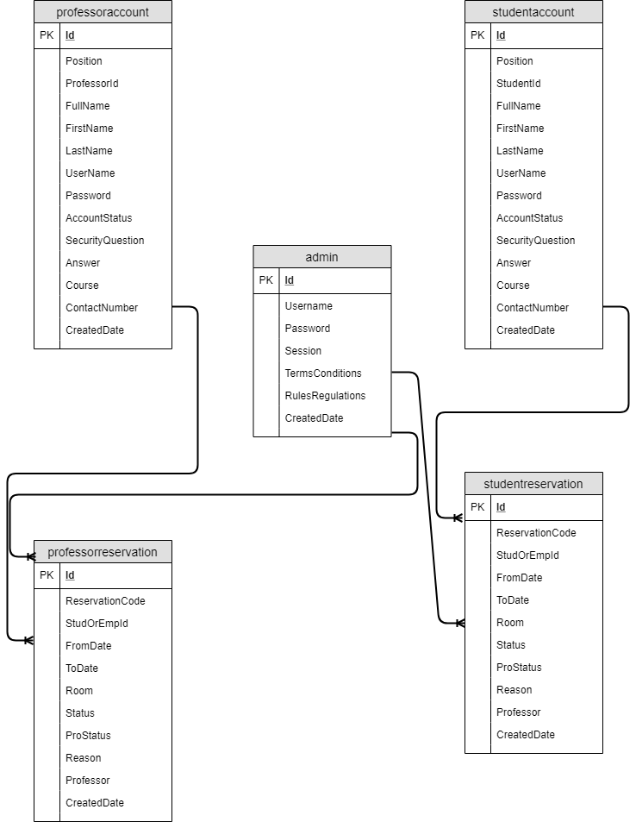

***Fig 16*** Entity-Relationship Diagram of PROSERVE

Fig 16 shows the relationship of each table in PROSERVE. There is a one-to-many relationship between students and or professors to the reservation made. Since students and or professors can make more than 1 reservation.

**Data Dictionary**

1. Account Status – the information of each borrower’s account whether Active or Inactive
2. Admin – System administrator
3. Contact Number – a cellular or landline number where users can be reached
4. Course – the degree that the borrower is taking (students)
5. Full Name – a given first and last name of the user
6. LAN – Local Area Network, group of computers or devices that share a common communications line
7. Position – borrowers category, student or professor
8. ProStatus – the current status of the projector on a specific reservation
9. Reservation Code – a Proserve’s auto-generated code
10. Security Question – a question that will serve as authentication when a borrower has forgotten the password
11. StudOrEmpId – the studentID or the employeeID of the student or borrower respectively
12. Username – identification used by the users that has registered to the system

**User Interface Design Specifications**

Here are the different web pages that PROSERVE has. The user will see the below Interfaces in each of the page.



***Fig 17*** PROSERVE - Home Page

Fig 17 shows the Home Page of PROSERVE, Projector Reservation System. The Home Page contains the Login and Registration button.

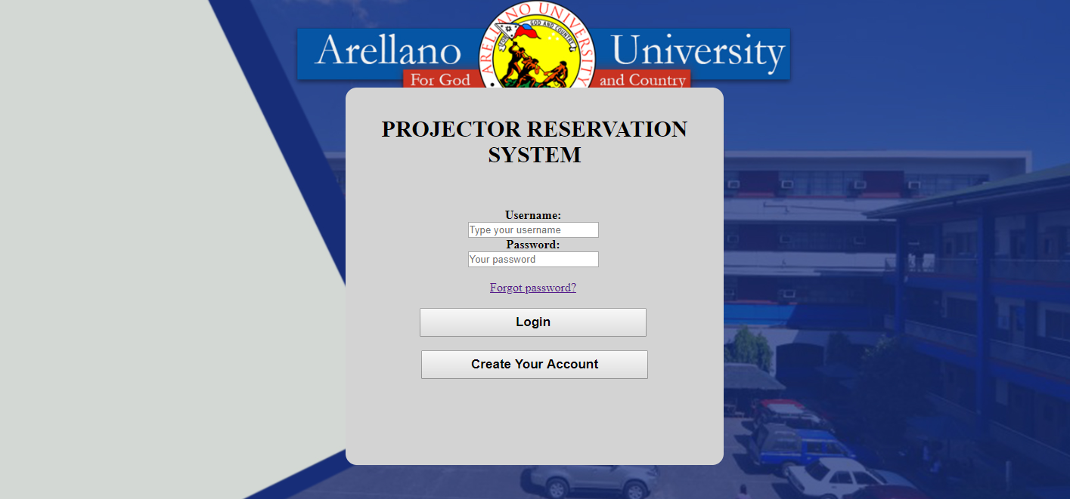

***Fig 18*** PROSERVE – Login Page

Fig 18 shows the login page for PROSERVE where the user has the option to enter the username and password or Create Account.

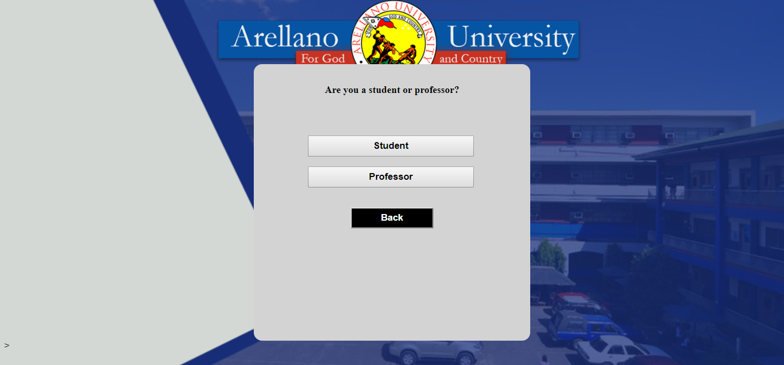

***Fig 19*** PROSERVE – Register Page

Fig 19 shows Register page where the users has to option to choose Student, Professor or Back.

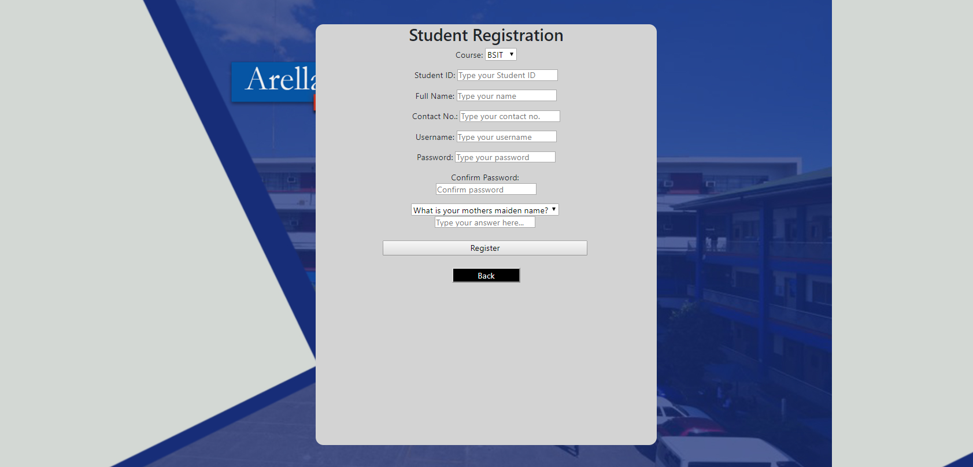

***Fig 20*** PROSERVE – Registration Page

Fig 20 shows the Student Registration page that has options to choose course, enter Student ID, Full Name, Contact Number, Username, Password, Security Question or Back.

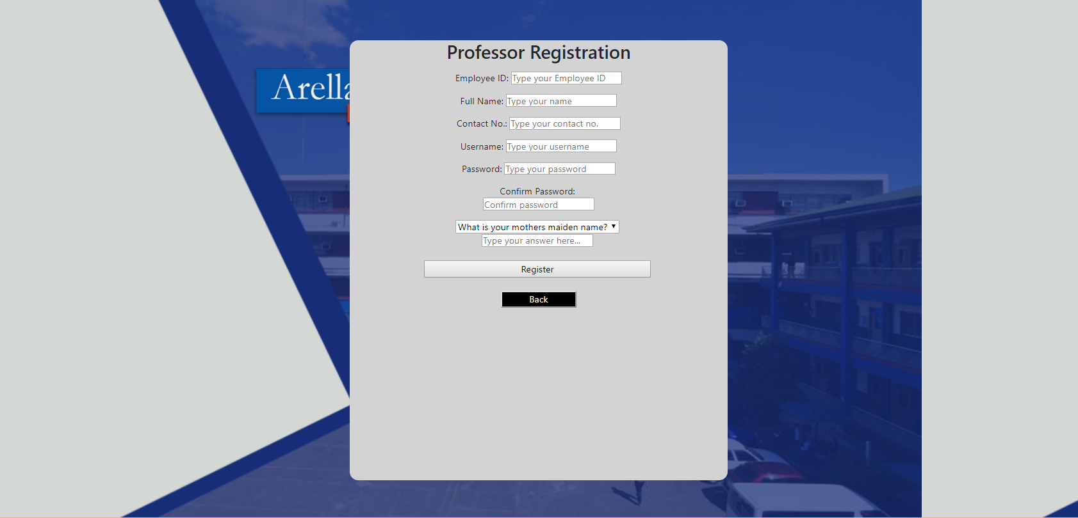

***Fig 21*** PROSERVE – Registration Page

Fig 21 shows the Professor Registration page that has options to enter Student ID, Full Name, Contact Number, Username, Password, Security Question or Back.

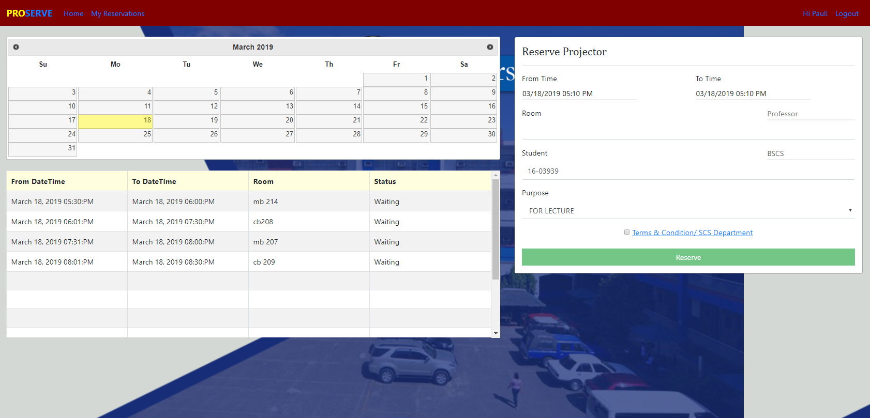

***Fig 22*** PROSERVE – User Home Tab

Fig 22 shows the user’s Home tab where the users can reserve the projector and see the list of reservations made on the selected date.

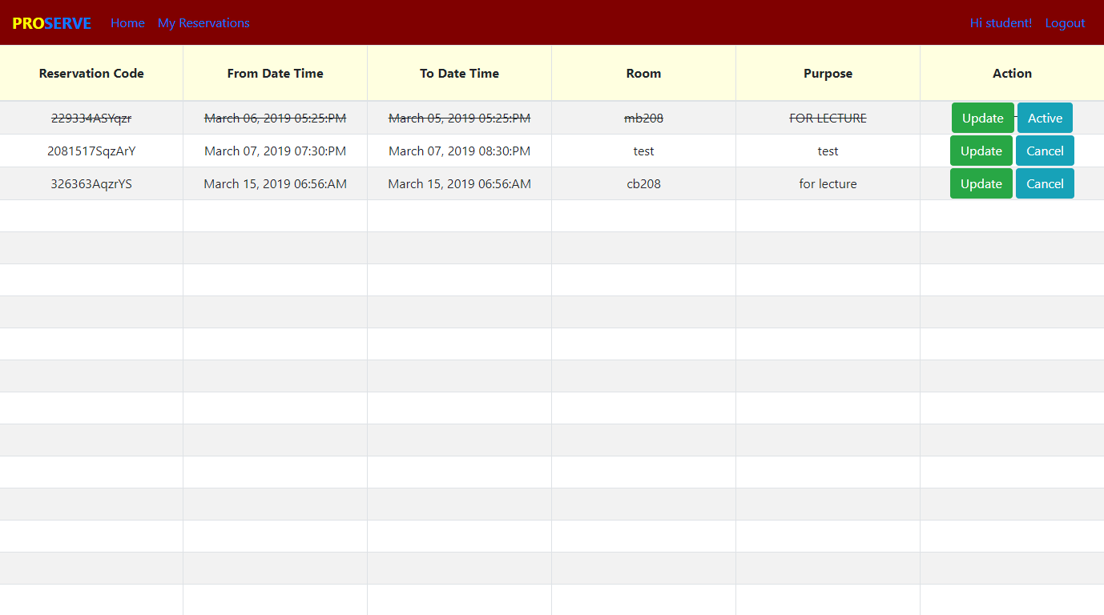

***Fig 23*** PROSERVE – User Reservation Page

Fig 23 shows user’s My Reservation page which shows the list of reservations made. The user can either change the status or reservation to Cancel or Active.

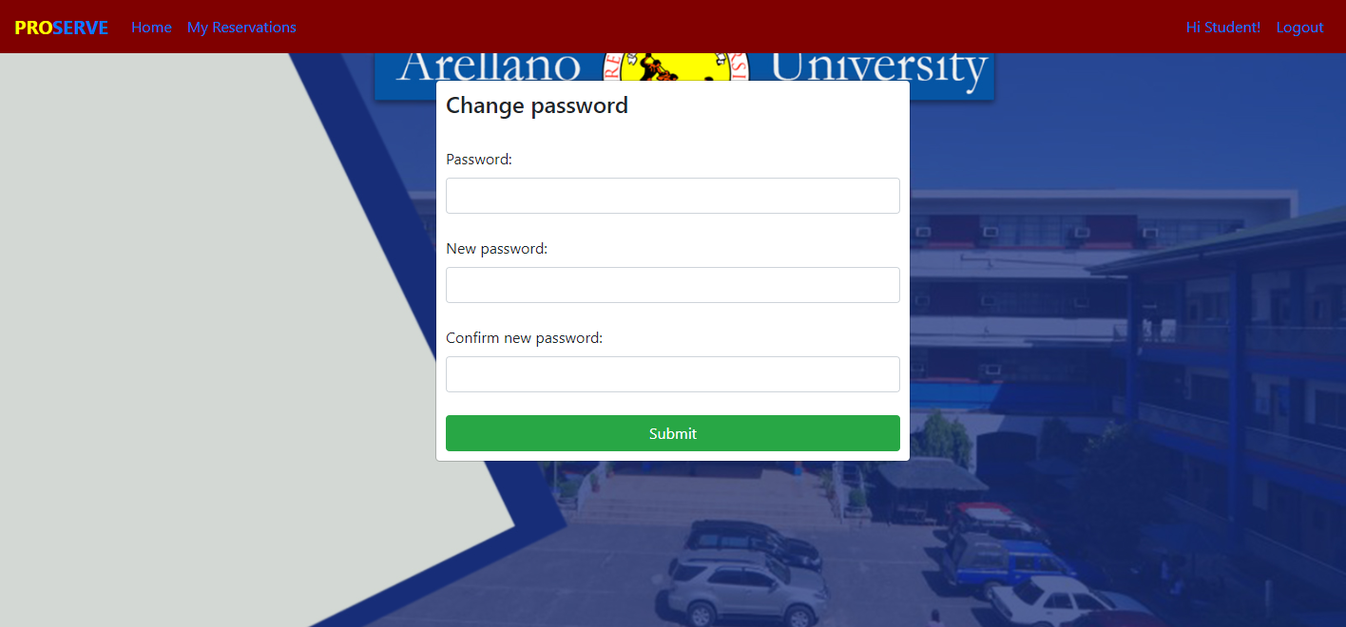

***Fig 24*** PROSERVE – Change Password

Fig 24 shows the page where the user can change the password.

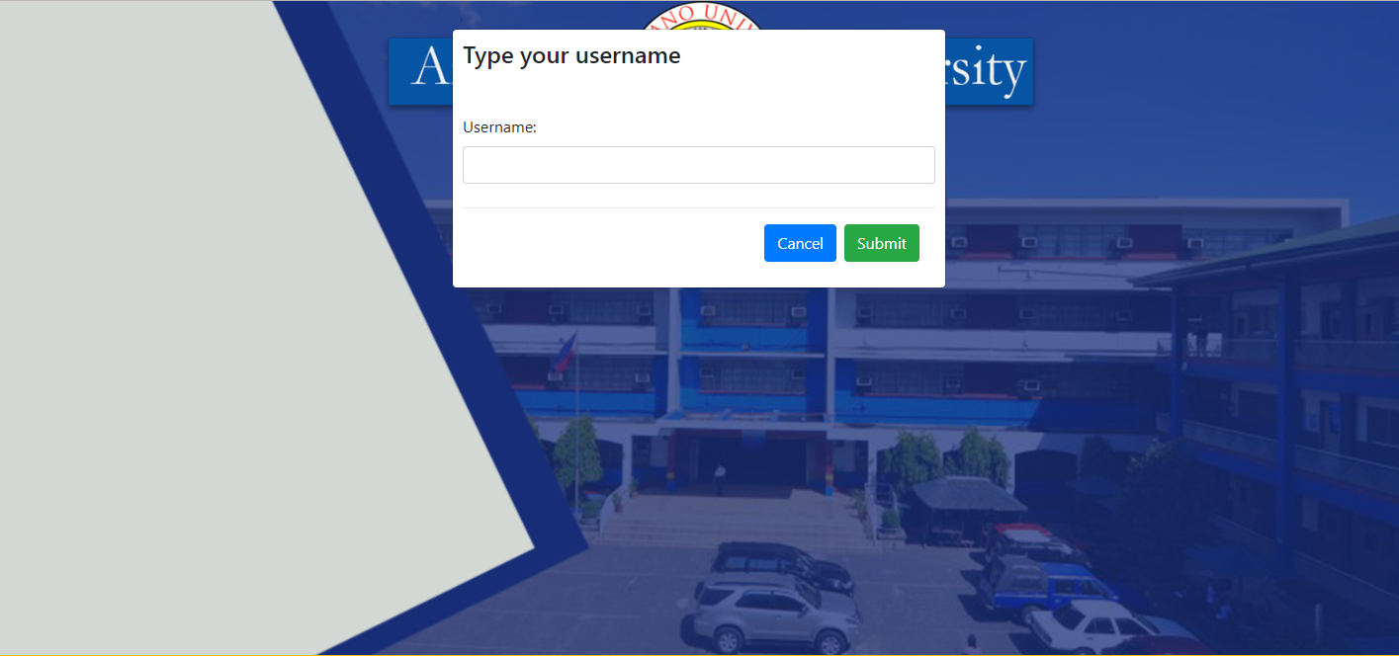

***Fig 25*** PROSERVE*–*Forgot Password

Fig 25 shows the Forgot Password interface where user has the option to enter username, Cancel or Submit.

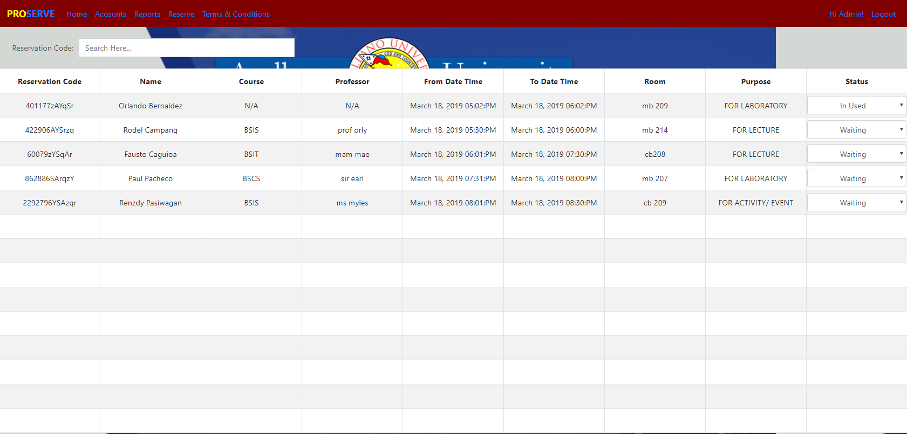

***Fig 26*** PROSERVE*–*ADMIN: Home Tab

Fig 26 shows Home Tab of the Admin account which shows list of reservations made on the present day where status can be changed to Released, Waiting or Returned.

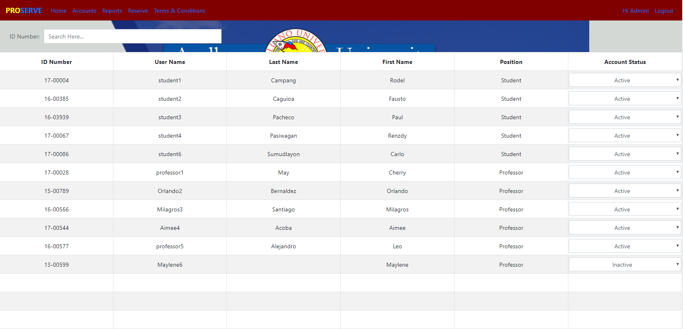

***Fig 27*** PROSERVE*–*ADMIN: Accounts Tab

Fig 27 shows the Admin Accounts tab which shows all the registered accounts where status can be changed to Active or Inactive.

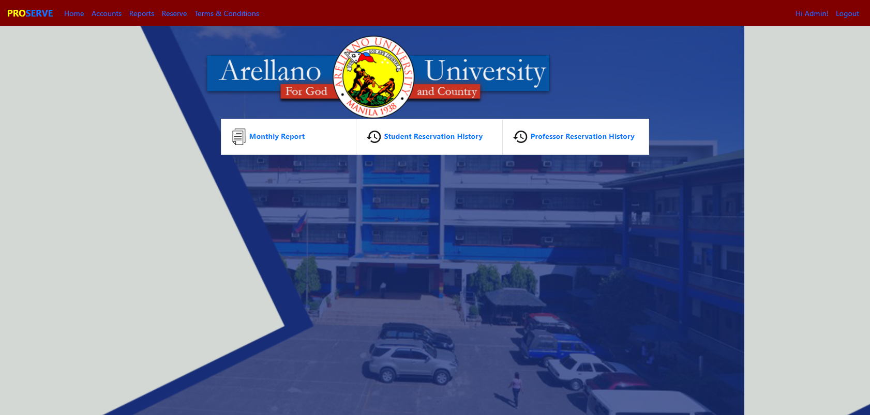

***Fig 28*** PROSERVE*–*ADMIN: Reports Tab

Fig 28 shows the Reports Tab where the Admin has options to choose Monthly Report, Student Reservation History and Professor Reservation History.

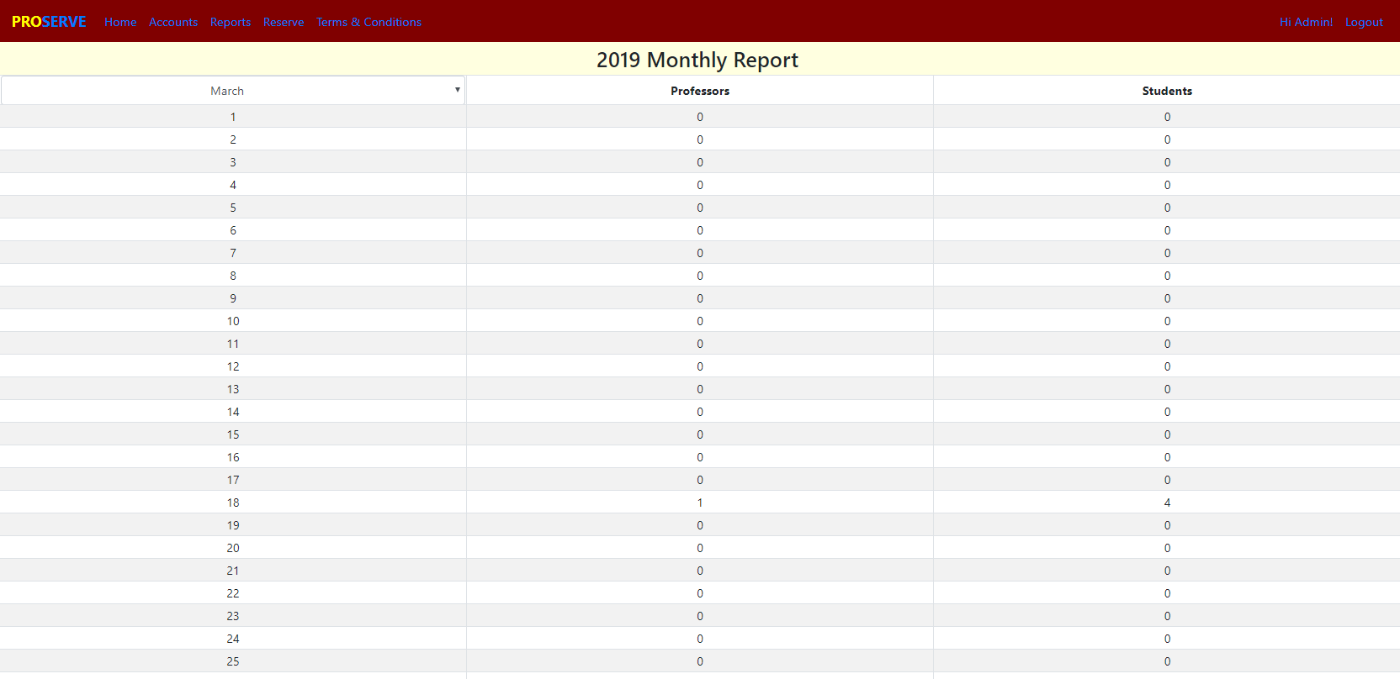

***Fig 29*** PROSERVE *–*ADMIN: Monthly Report Page

Fig 29 shows the Monthly Report Module where the Admin can see the number of reservations made by each users.

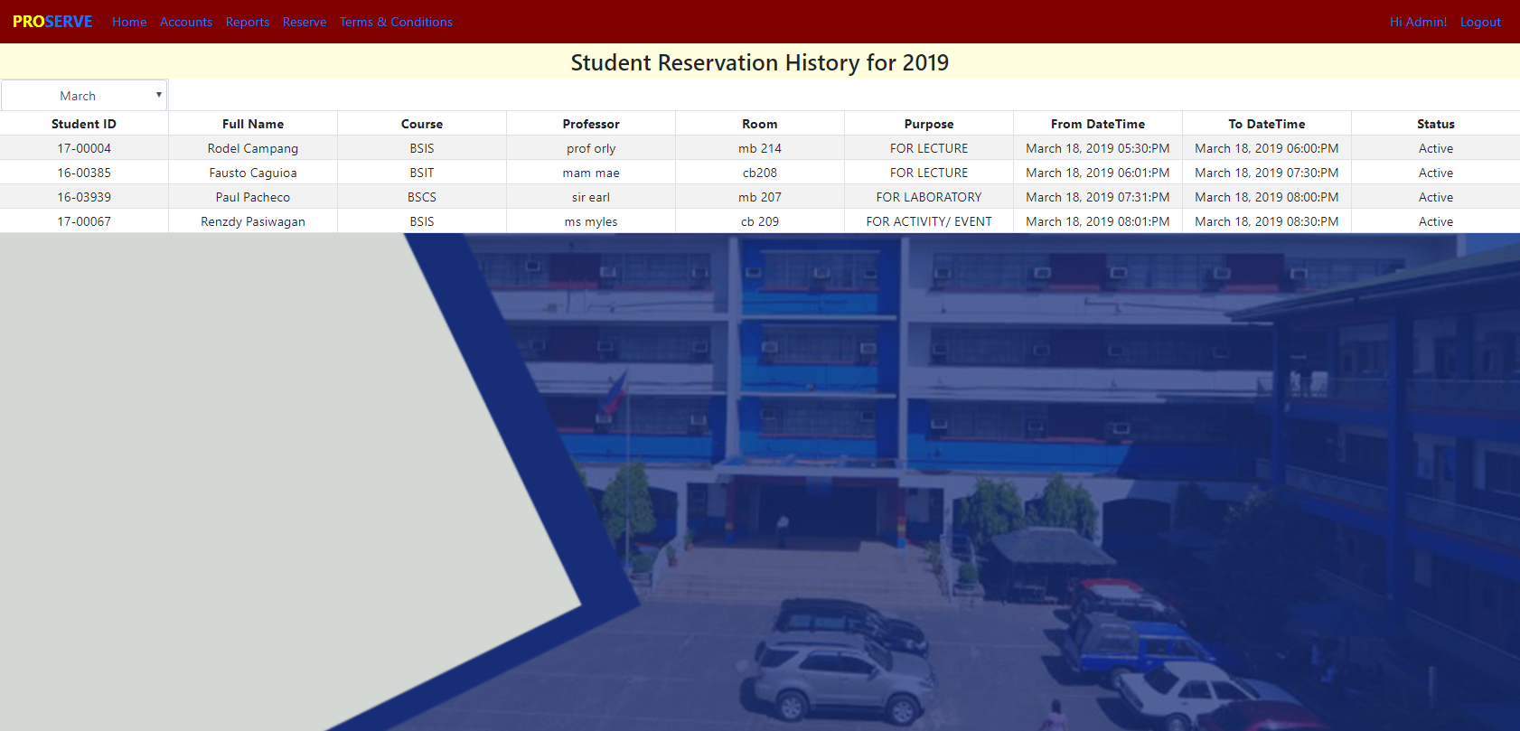

***Fig 30*** PROSERVE*–* ADMIN: Student Reservation History Page

Fig 30 shows the Admin Student Reservation History Report which shows the detailed reservations made by the Students and can be filtered by month.

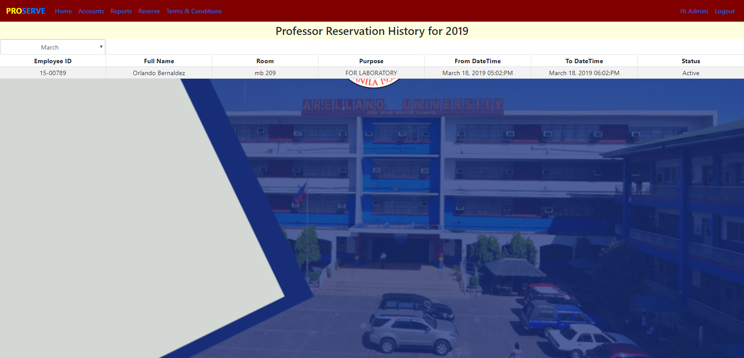

***Fig 31*** PROSERVE*–*ADMIN: Professor History Report Page

Fig 31 shows Admin Professor Reservation History Report which shows the detailed reservations made by the Professor and can be filtered by month.

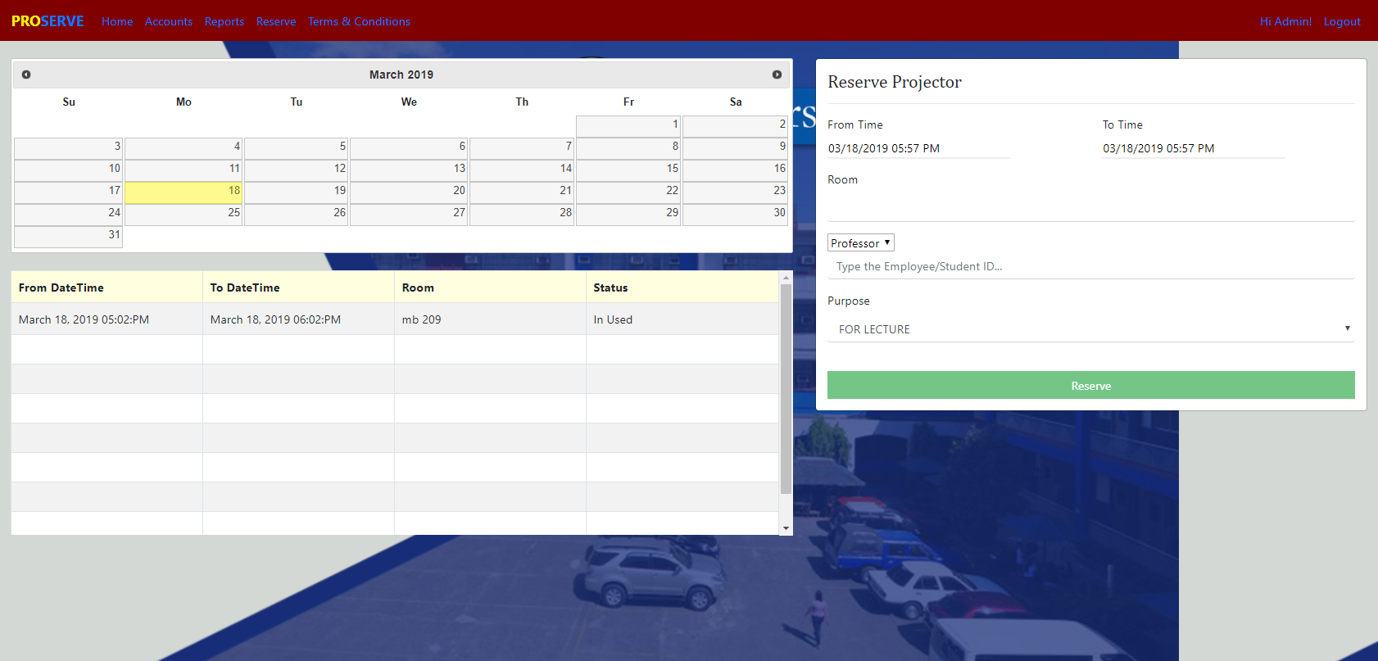

***Fig 32*** PROSERVE*–*ADMIN, Reserve Tab

Fig 32 shows the Admin Reserve tab where the projector can be reserved and see the list of reservations made on the selected date.

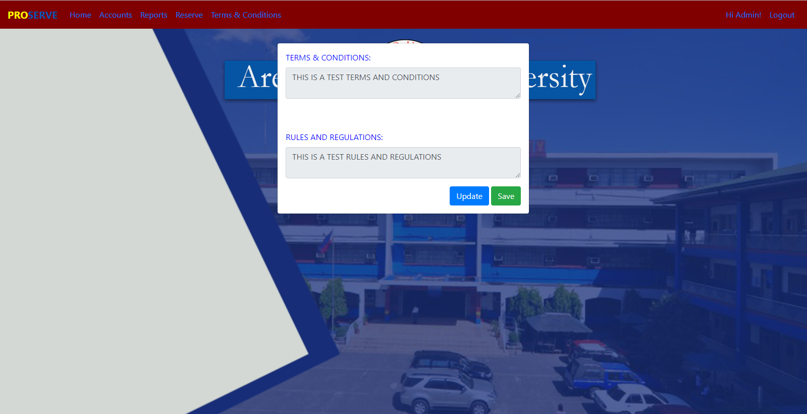

***Fig 33*** PROSERVE*–*ADMIN, Terms and Conditions Tab

Fig 33 shows the Admin Terms and Conditions’ Tab where the Terms and Conditions and Rules and Regulations in reserving the projector can be updated.

**Report Requirement Specifications**

To see the historical data of the reservation made the users, a report module is made available on the admin’s side. There are three available report reports.

1. Monthly Report: This report shows the total number of reservations made by the users per day that can be filtered by month.
2. Student Reservation History: This report shows the detailed reservation made by each student which can also be filtered by month.
3. Professor Reservation History: This report shows the detailed reservation made by each professor which can also be filtered by month.

**System Limitations**

The system can only be accessed through the University’s Local Area Network. Since the main users of the system are limited to SCS students and Faculty members, unauthorized users will be deactivated manually by the Admin. The availability of the projector will not be obtained by unregistered users.

1. **APPENDICES**

**Appendix A**

**Gantt Chart**

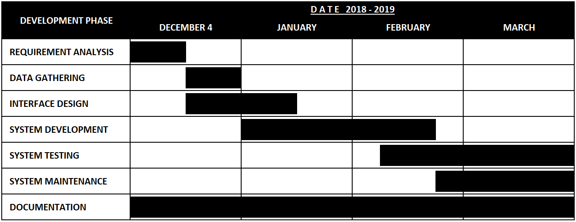

**Appendix B**

**System Requirements**

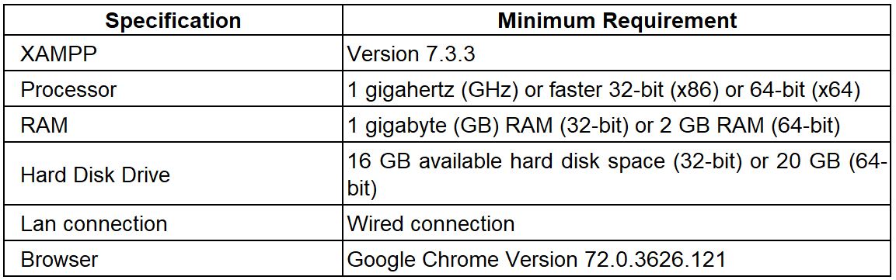

# **References**

*Advantages of Computer Data Processing*. (n.d.). Retrieved from studopedia.org: https://studopedia.org/9-153686.html

ConceptDraw. (n.d.). *Hotel reservation system*. Retrieved from ConceptDraw: https://www.conceptdraw.com/examples/manual-reservation-process

*Equipment Booking*. (2017, September 19). Retrieved from Western Sydney University: https://www.westernsydney.edu.au/research/centralised_research_facilities/equipment_booking

Hope, C. (2017, October 30). *Projector*. Retrieved from Computer Hope: https://www.computerhope.com/jargon/p/projecto.htm

Whitaker, C. (2018, June 25). *The Advantages of Using a Projector in the Classroom*. Retrieved from CLASSROOM: https://classroom.synonym.com/advantages-using-projector-classroom-7884259.html